**Kids Zone**

|  |  |  |
| --- | --- | --- |
| **Supervisor.** | **Muhammad Najam Professor** | |
| **Batch.** | **PR2-2022G1** | |
| **Group.** | **A** | |
| **Serial No** | **Enrollment Number** | **Student Name** |
| **1** | **1391917** | **Hammed Hussain** |
| **2** | **1396282** | **Muzamil** |
| **3** | **1394863** | **Noman Khan** |

**ACKNOWLEDGEMENT**

**The first, we Would like to express my special thanks of gratitude to my teacher <<Muhammad Najam>> , who helped us a lot in finalizing this project with in the limited time frame, valuable in counseling and assistance for the accomplishment of the project.**

**Secondly we would also like to thanks the eProject team at Aptech Head Office, who gave the us opportunity to do this wonderful Project about Kids Zone**

**Thirdly, We also thank the Project team, Some of the benefit are us under :**

* **Re-enforcement of skills happens in the experiential learning process;**
* **A mentor, ensuring that we do net get drifted constantly guides us**
* **It gives us a lot of confidence to face in interview as we a have worked project.**

**CUSTOMER REQUIREMENT**

**SPECIFICATION (CRS)**

**The Web site is to be created based on the following requirements.**

**1) Home page must be designed by including various interactive images like of a**

**child say prayer, brushing teeth, drinking milk and so on.**

**2) Navigation links must be included and must be designed in an interactive way**

**so as to become more user friendly for the kids.**

**3) Font sizes must be selected appropriately thinking about the end users.**

**4) Navigation must be made user friendly.**

**5) Menus can be included such as :**

* **ABC.s**
* **Abc . s**
* **123….**
* **Table of 2, 3,4, 5**
* **Some nursery rhymes with relevant images.**
* **Basic colors**
* **Some animals**
* **Some Vegetables**
* **Sunday, Monday…**
* **January, February**
* **Addition (here allow the end user to enter the value and message must be**
* **prompted whether correct as or incorrect)**

**- Subtraction (here allow the end user to enter the value and message must be**

**prompted whether correct as or incorrect)**

**6) Look and feel must be made user friendly.**

**7) Uniformity and Navigation must be made smooth throughout the website.**

**SCOPE OF THE WORK (IN BRIEF)**

**The website is to be developed for the Windows Platform using HTML5,**

**JavaScript and Geolocation. The site should work well in all leading browsers**

**Including Chrome, IE, Firefox etc..**

**Homepage show Top best sell items, big sale, collection, new shop...**

**Every content direct to relative content.**

**TASK SHEET REVIEW**

|  |  |  |  |  |  |  |
| --- | --- | --- | --- | --- | --- | --- |
| **Project Ref. No.:eP/**  **Advertisement Portal Management System/01** | | **Project**  **title** | **Date of Preparation of Activity Plan** | | | |
| **No** | **Task** | **Kids**  **Zone** | **Actual**  **Start Date** | **Actual**  **Day** | **Team-Mate**  **Names** | **Status** |
| **1** | **Check color**  **format, size,**  **JavaScript,**  **responsive in the**  **Home page** | **DD/MM/YY** | **2** | **Student 1** | **Complete** |
| **2** | **Check color**  **format, size,**  **JavaScript,**  **responsive in**  **About page and**  **meat Line-up** | **DD/MM/YY** | **2** | **Student 1** | **Complete** |
| **3** | **Check color**  **format, size,**  **JavaScript,**  **responsive in**  **Animal Page, Fruit Page**  **Vegetable Page** | **DD/MM/YY** | **2** | **Student 1** | **Complete** |
| **4** | **Check color**  **format, size,**  **JavaScript,**  **responsive in Phonics Page**  **Mathematic Page .**  **Contact Page** | **DD/MM/YY** | **2** | **Student 1**  **Student 2** | **Complete**  **Complete** |
| **5** | **Write a**  **developer guide** | **DD/MM/YY** | **2** | **Student 1** | **Complete** |

**Home Page**





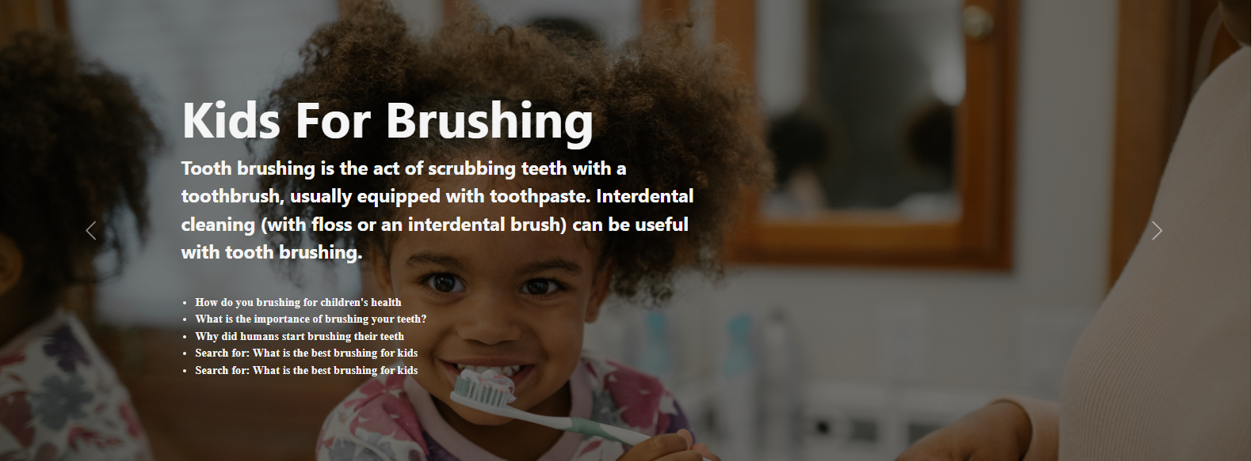

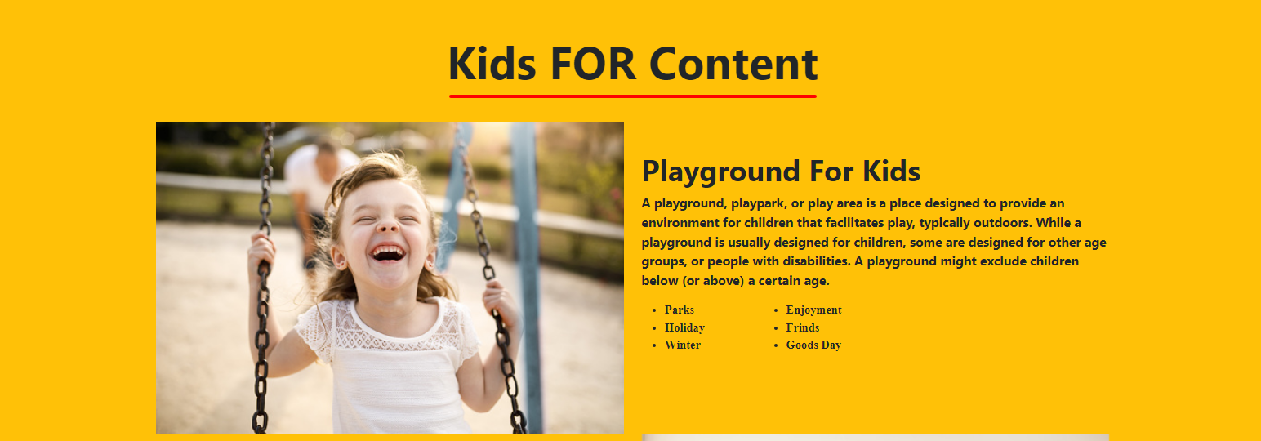



**Activity**

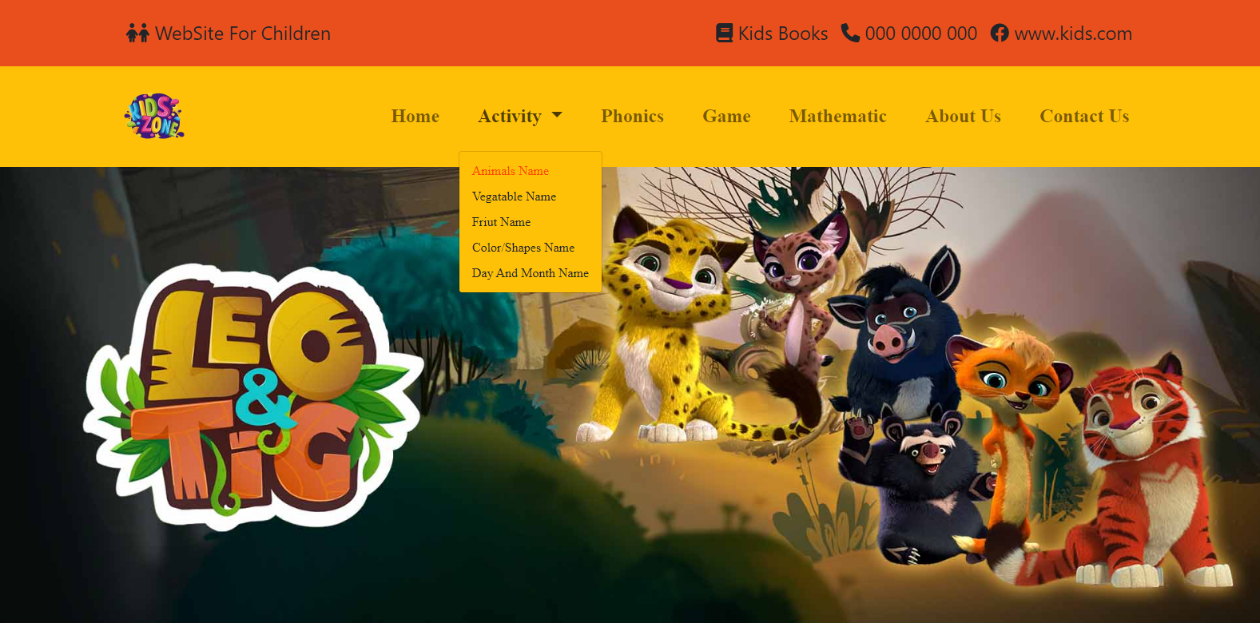

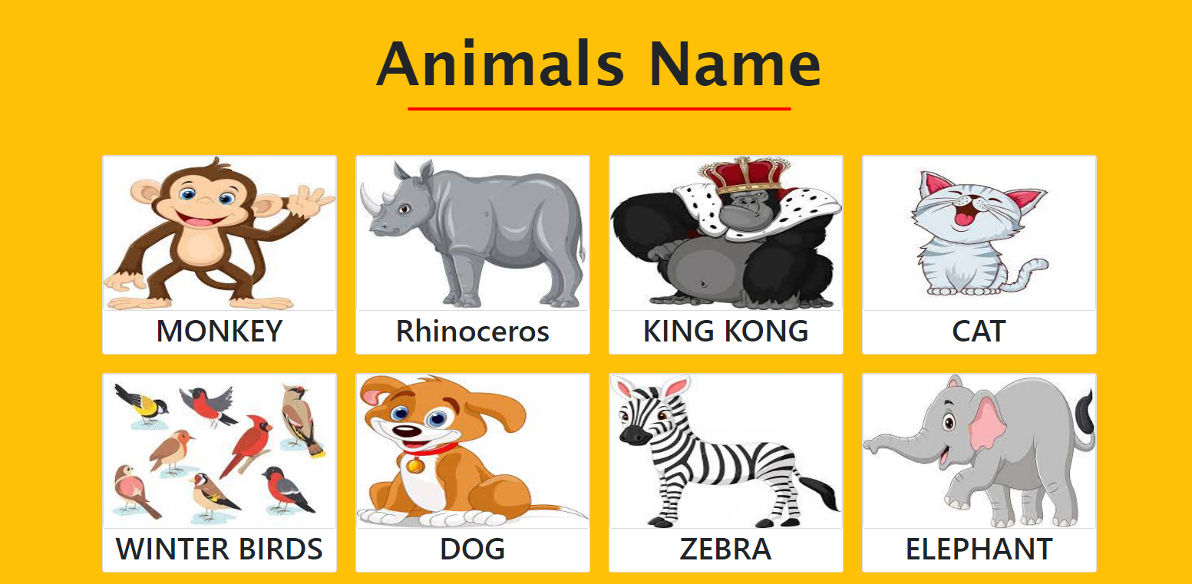



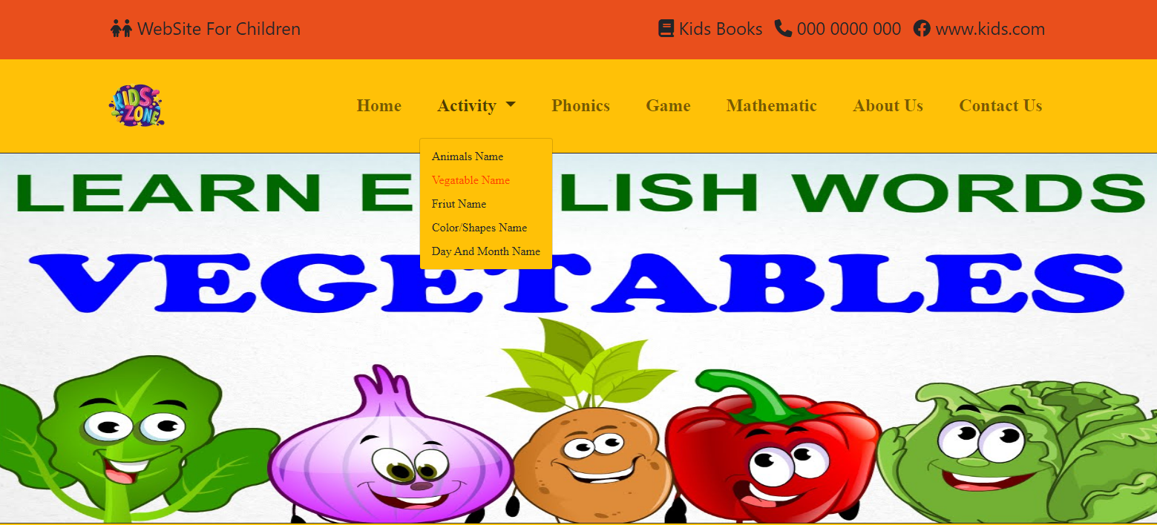

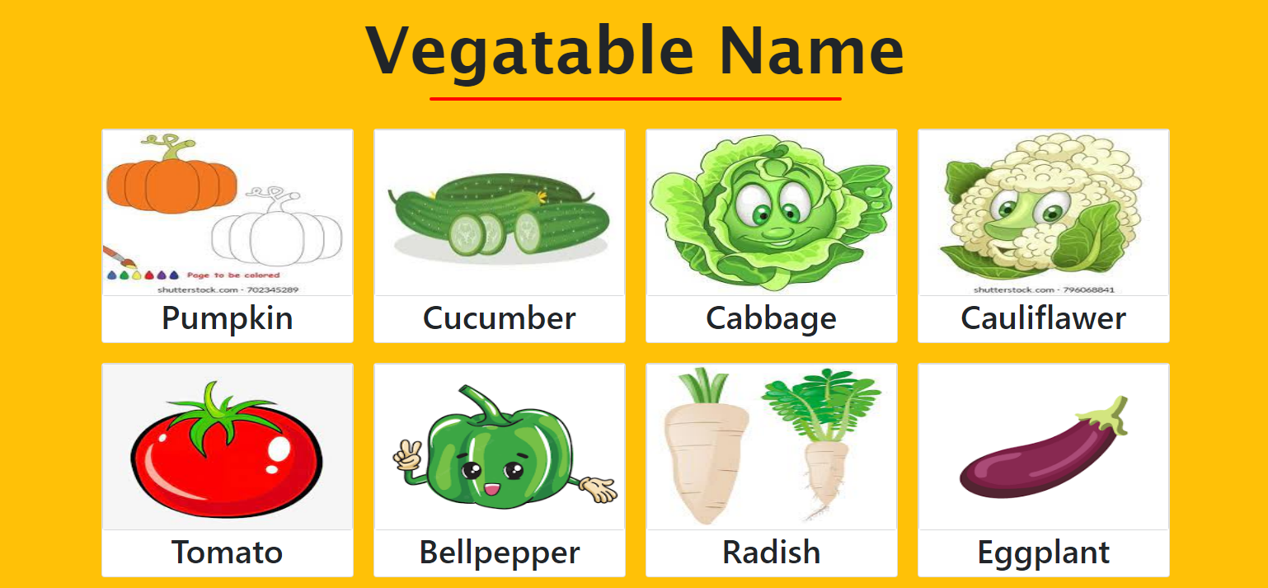



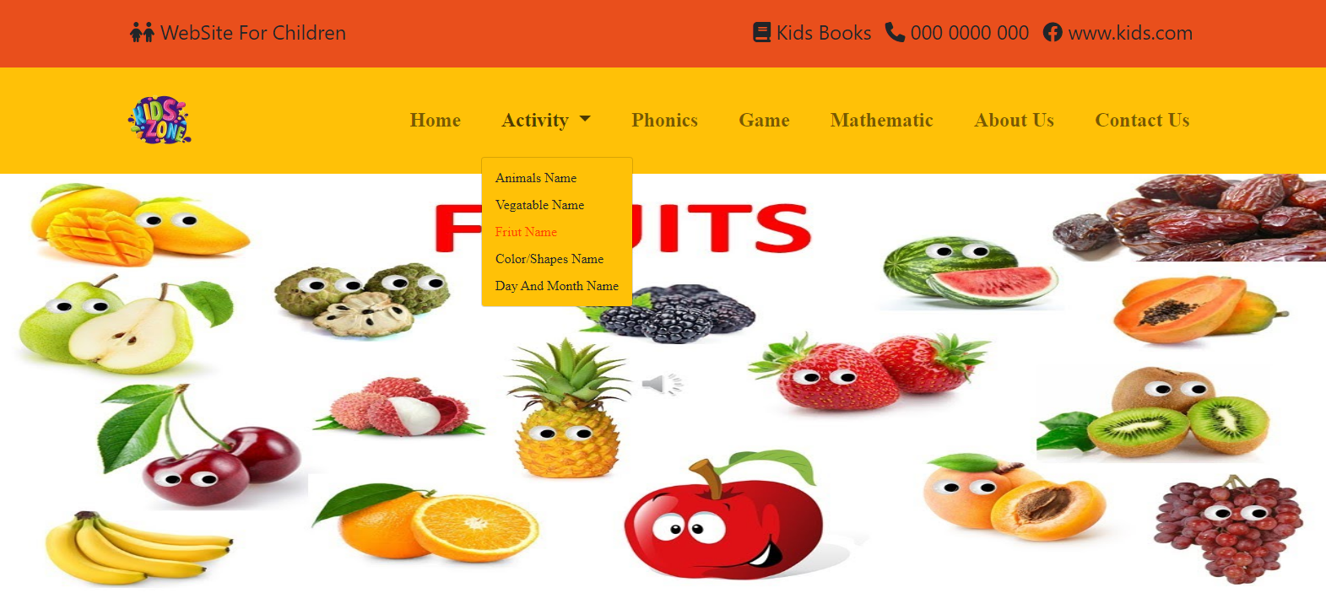

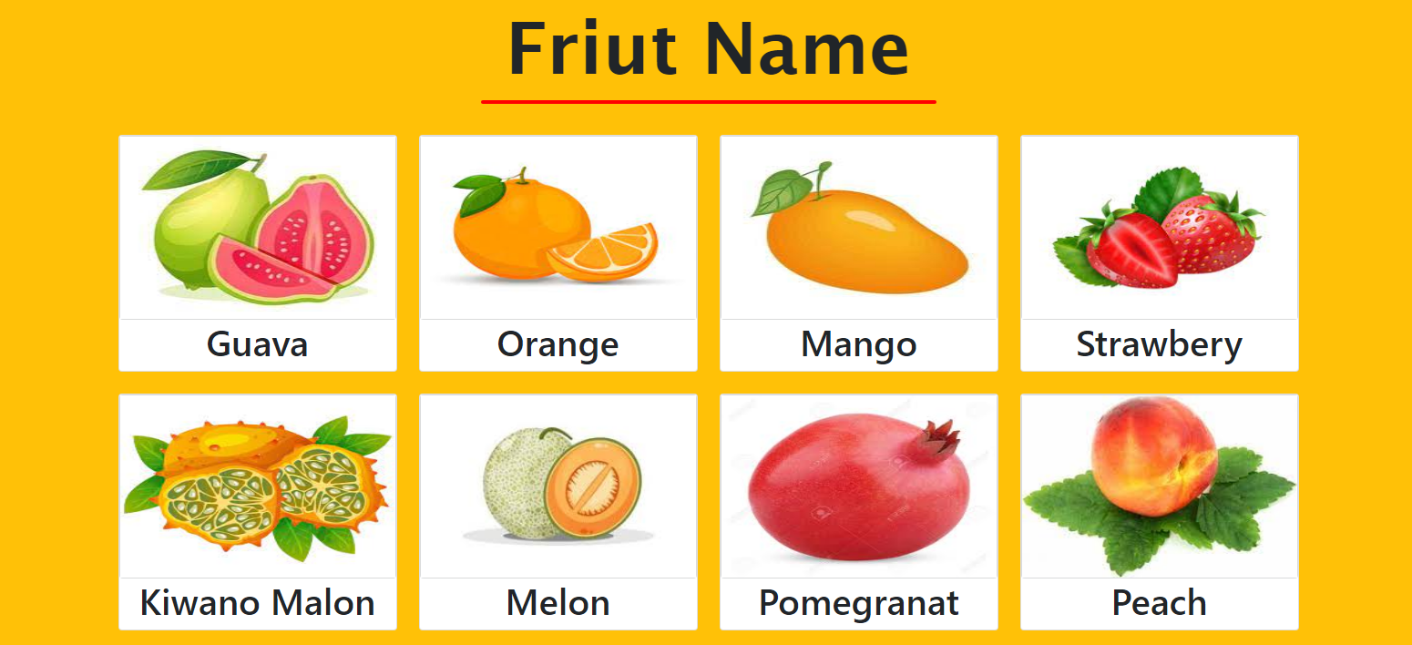



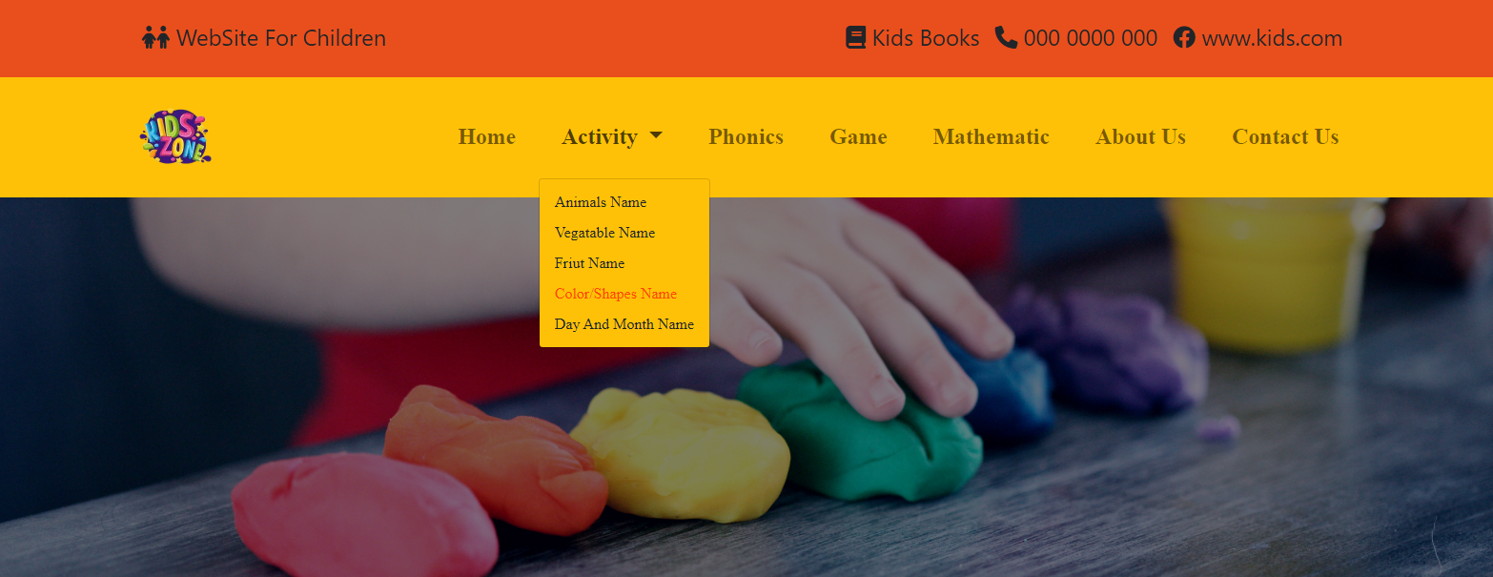

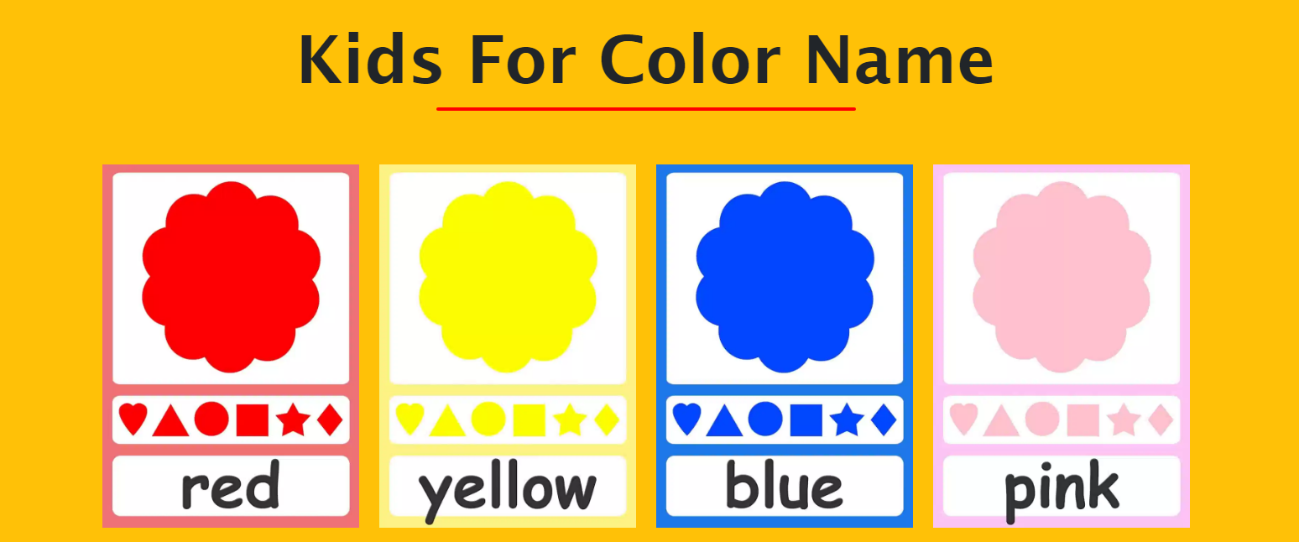

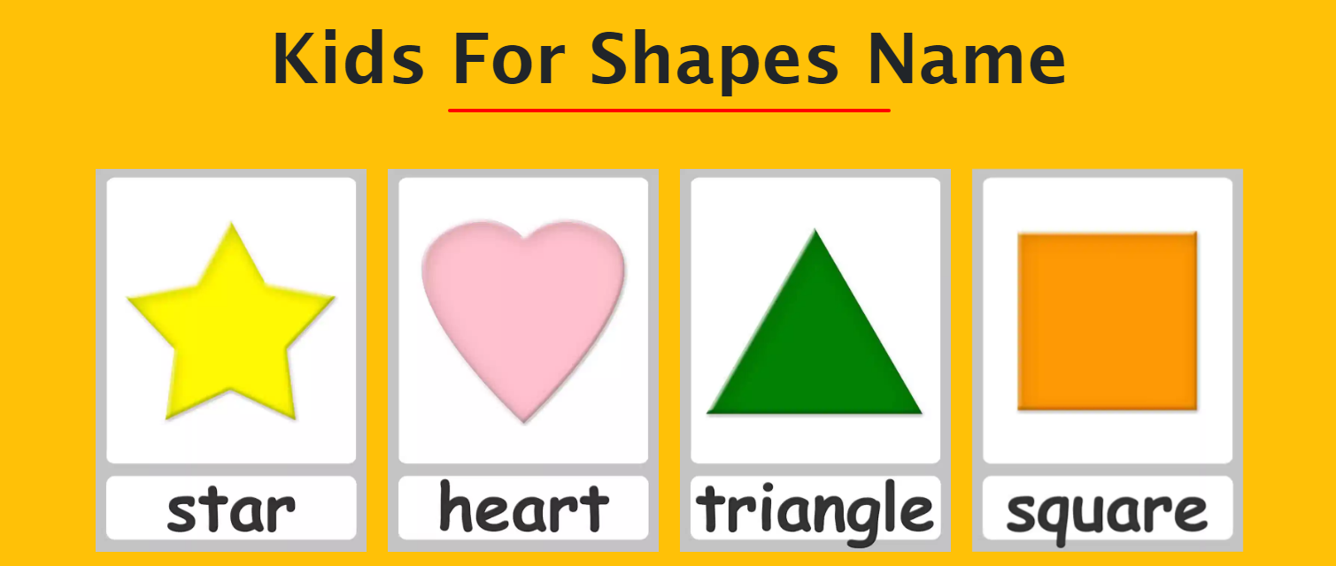





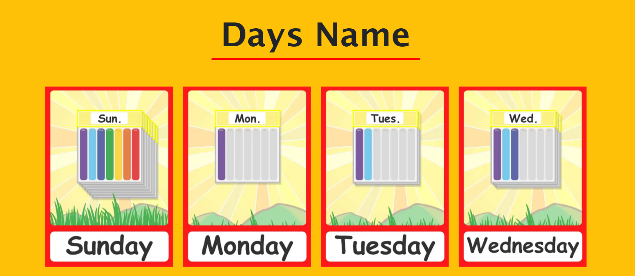

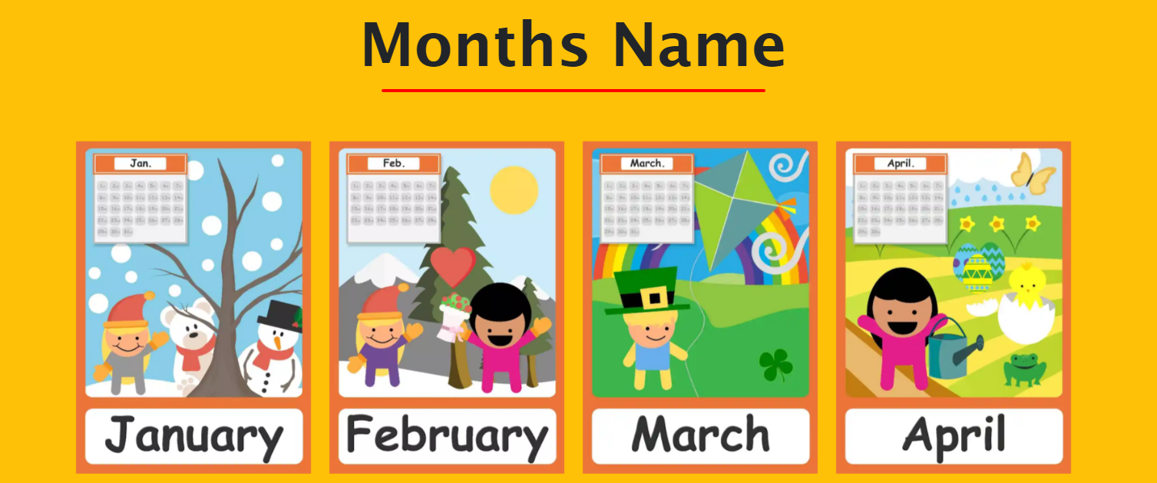

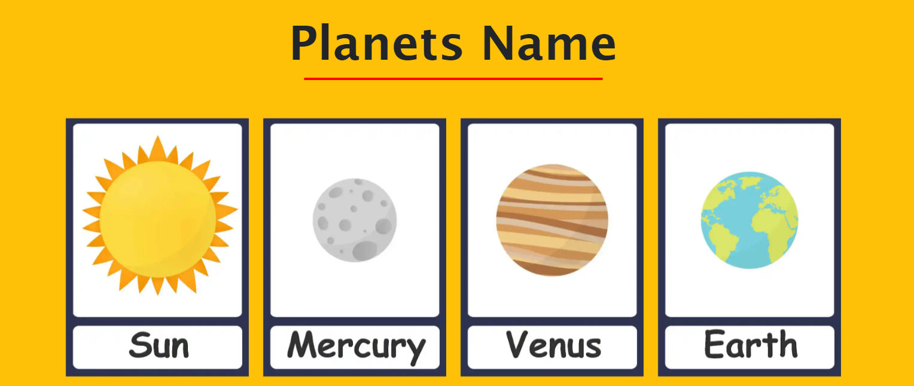



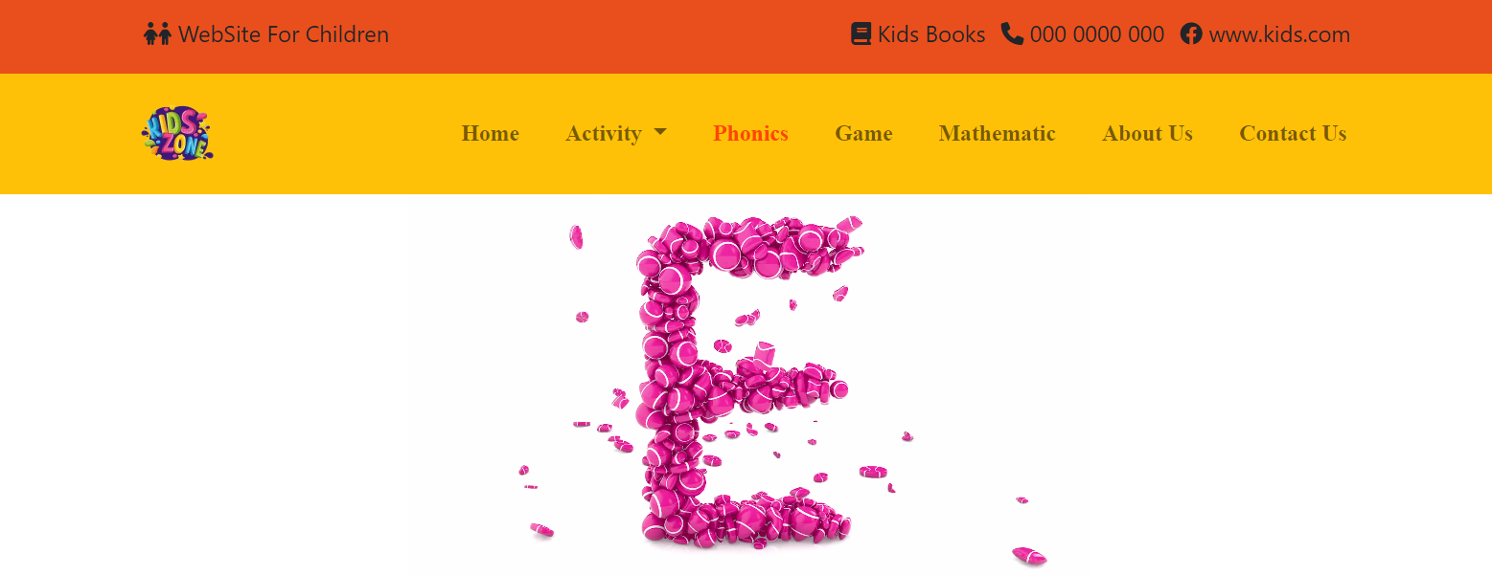

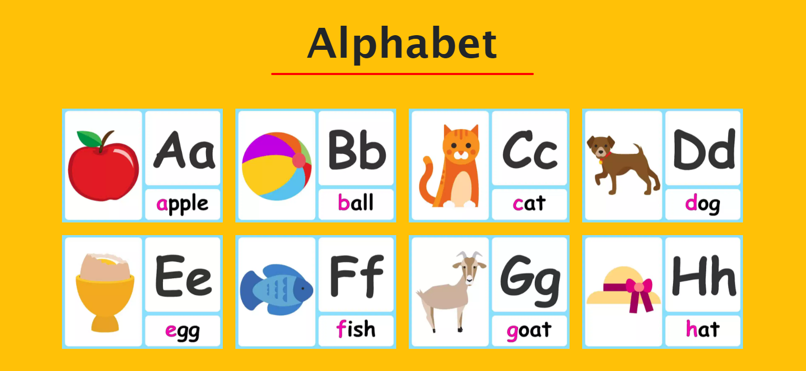

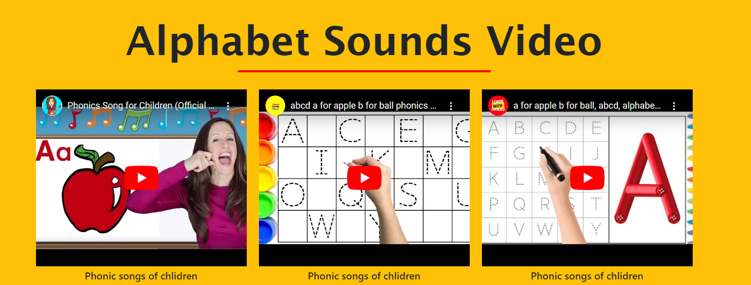

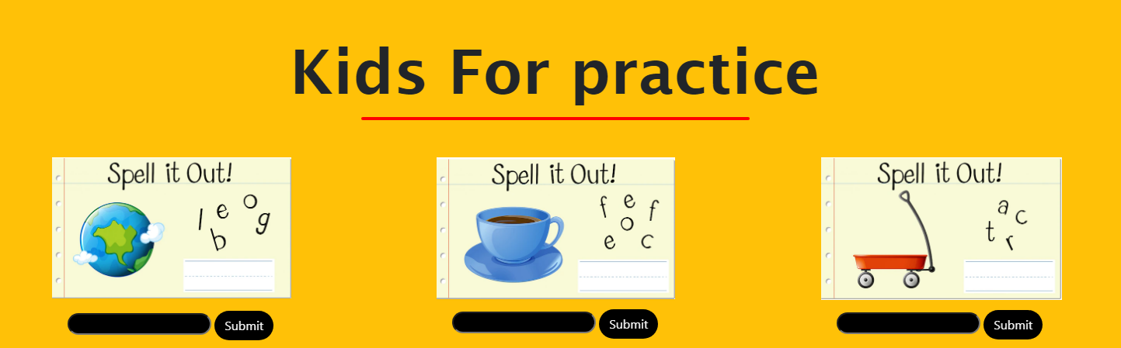





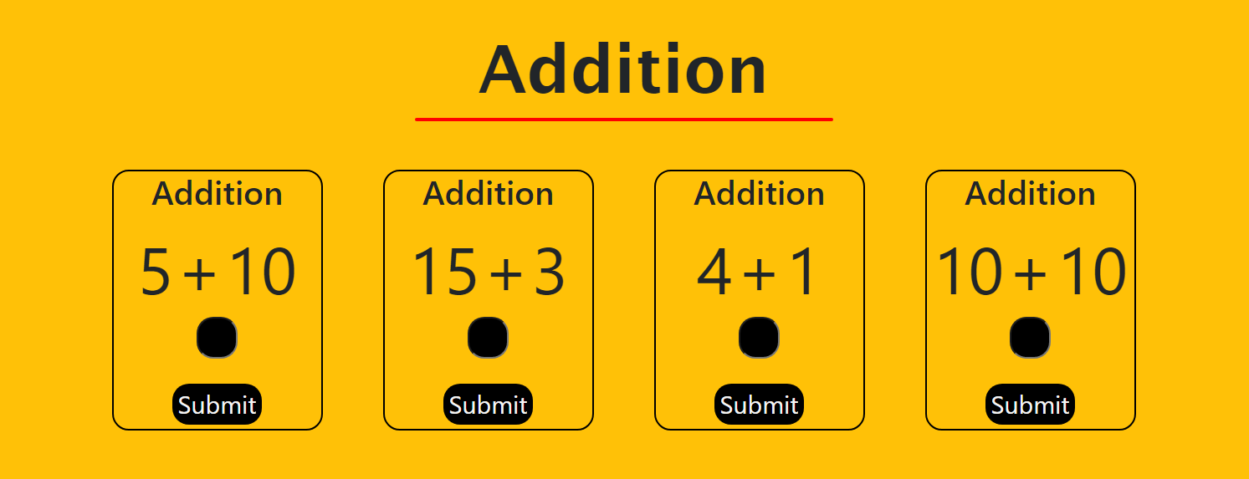

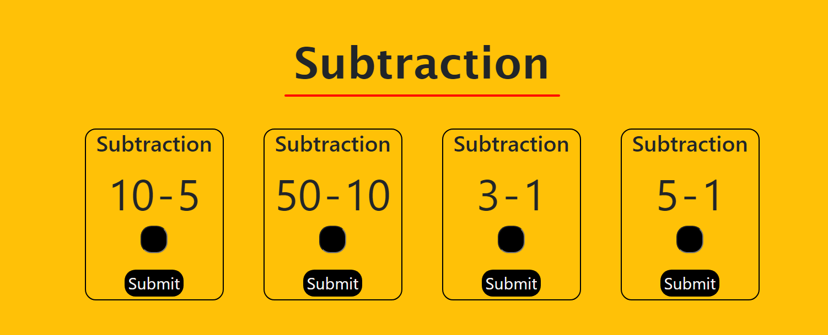

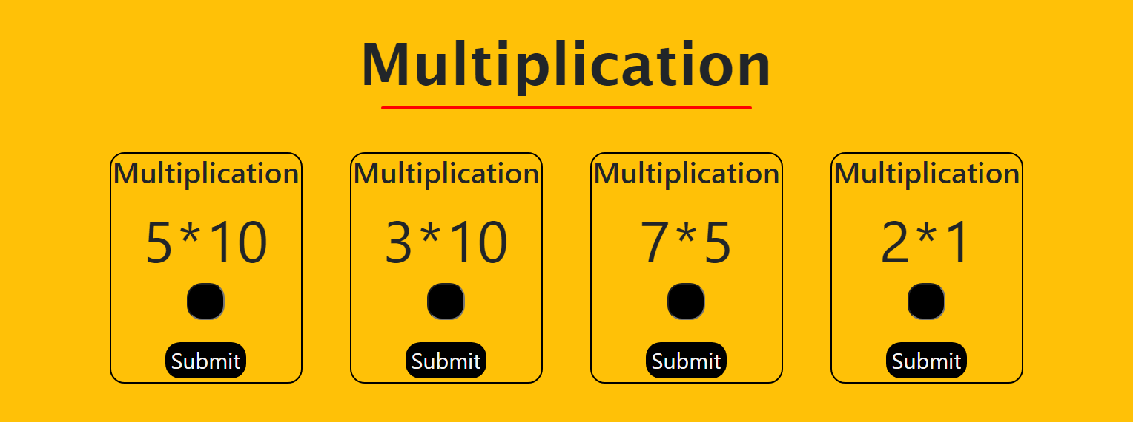

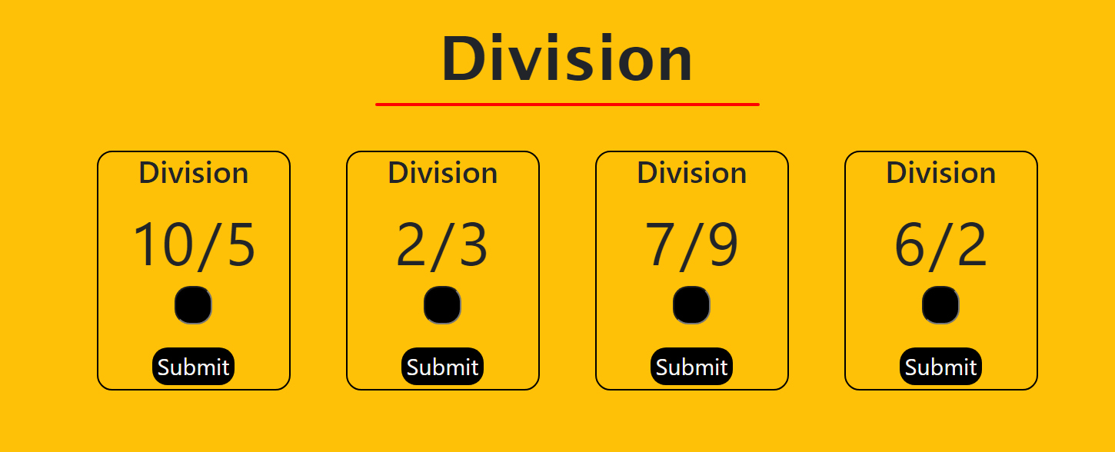



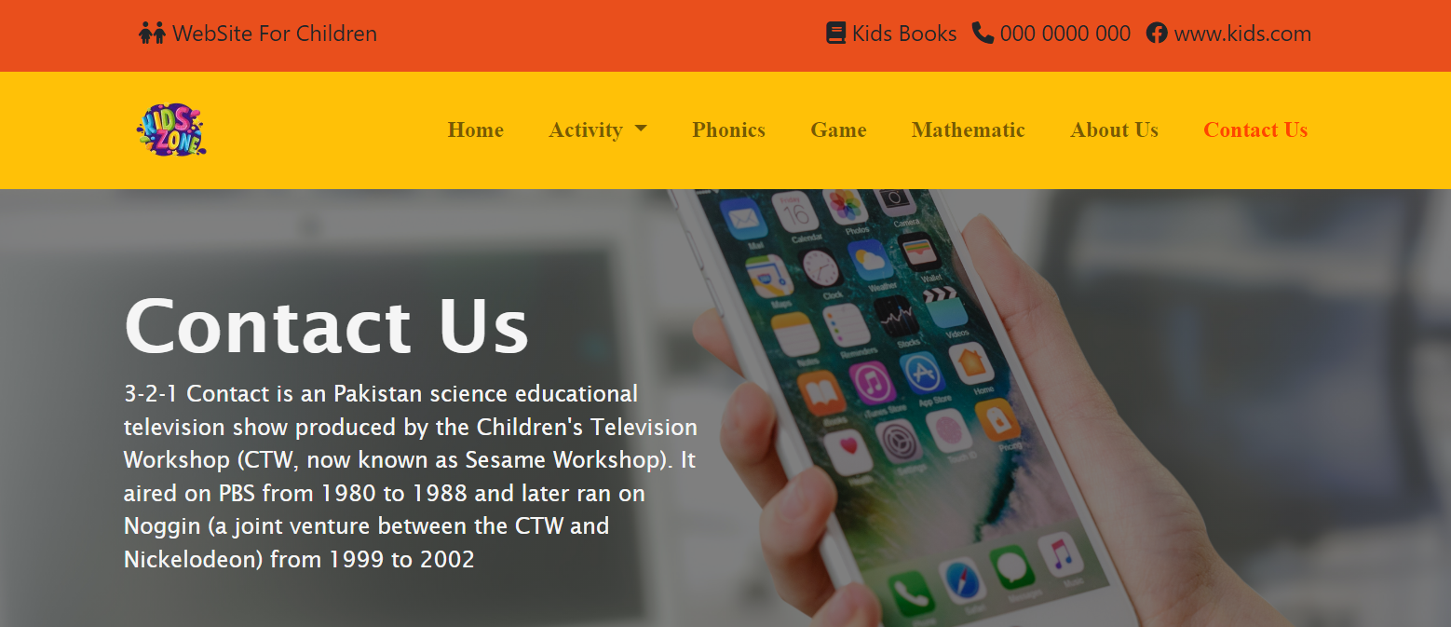

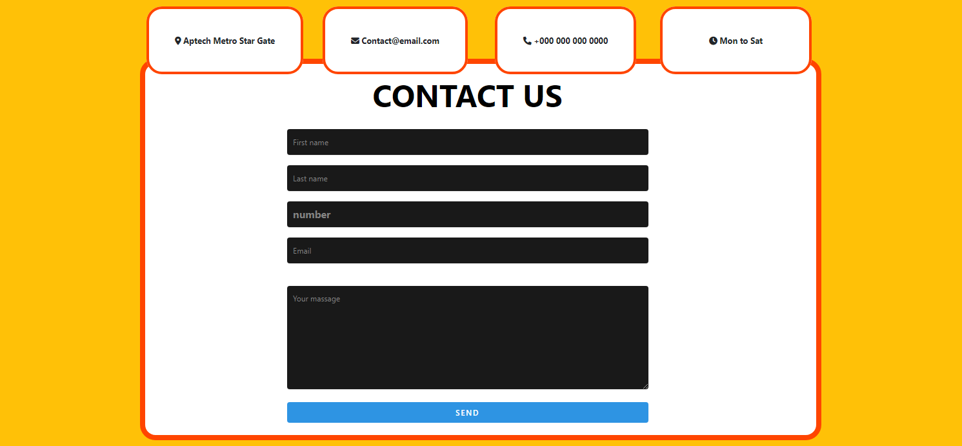

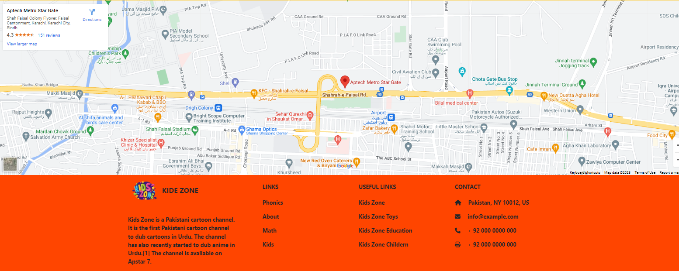

**Home Page**

**Kids Contant**

**Contact Us**

**Map AND Form**

**Game Mathematics**

**Mathematics**

**Phonics Page**

**Activity**

**Animals Vegetable Fruit Color Day Month**

**About Page**